**Atomic Theory**

Evidence for atoms

* Law of conservation of mass
* Brownian motion
* Atom comprises of charged objects that are not uniformly distributed
  + Geiger-Marsden experiment
  + Deflection of alpha particles

Ideal gas

* Atoms do not interact with each other
* PV = nRT
  + R = 8.314 J/molK
* PV = NkBT
  + kB = 1.38 x 10-23 m2kgs-2K-1 (Boltzmannn constant)
  + R = kB x NA where NA = 6.02 x 1023 (Avogadro’s number)
* 0 K = -273.15 C
* Lower temperatures – less ideal

Kinetic energy (ideal monoatomic gas)

* Avg KEatom = 3/2 kBT
  + PV = 2/3 N (KEatom)
  + Avg KETotal = 3/2 NkBT = 3/2 nRT

Heat capacity

* Heat capacity: amount of thermal energy needed to raise an object’s temperature by 1K
* Specific heat cap: heap capacity/mass
* Latent heat of fusion/vaporisation: liquid-solid / liquid-gas
  + 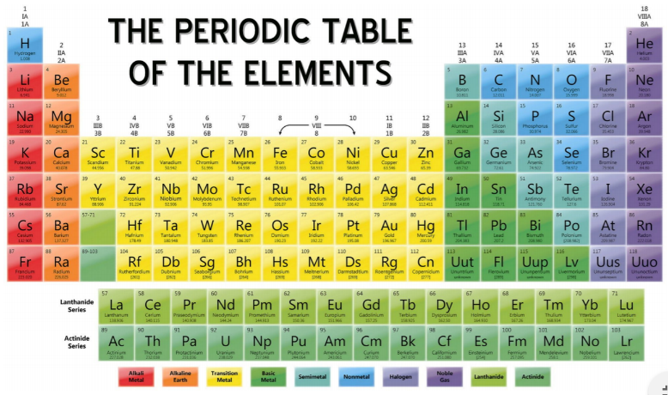Substance’s temperature does not change, heat used to break bonds causing change in phase

**Classical Atoms and Electrical Forces**

Periodic table

* Periodic table representation:
  + top - no. of protons
  + bottom - mass number (protons + neutrons)
* Also arranged by how electron orbitals are filled (spdf orbitals)

Electric charges

* 1 electron = 1.6 x 10-19 C
  + C = coulomb
* Conservation of charge in an isolated system
* Different materials have different tendencies to donate/receive electrons
  + Triboelectric series
* Coulomb’s law: Force between 2 point charges

$$F=\frac{kq_{1}q_{2}}{r^{2}}$$

Electric field strength (E)

* Density and direction of lines indicated strength and direction of force a positive test charge would face
 $$E=k\frac{q}{r^{2}}$$

 $$F=qE$$

+ k = 9.0 x 109 Nm2 C-2
* Inverse-square law form: electrons orbit around nuclei, similar to satellites around planets due to gravity
  + However, quantum mechanics changes trajectories of electrons
  + Location of electrons only probabilistic
* An orbiting/accelerating electron causes electric field lines far away to oscillate/distort, perceived as EM radiation (aka light)
* Classical physics – uniform circular motion of an electron implies constant centripetal acceleration of electron, causing it to emit EM radiation constantly
  + Implies loss of energy
  + Implies spiralling into the atom
  + Implies unstable atoms
  + Cannot describe actual atoms

A close up of a logo

Description generated with high confidence

**Quantum Atom**

Electric potential energy

* Electric potential energy: work done by q1 electric field to move charge q2 from distance r to infinity
$$U=\frac{\left(kq_{1} q_{2}\right)}{r}=Fr$$

* Total energy (of a resting proton) = KE of orbiting electron + PE between proton and electron
 $F =\frac{mv^{2}}{r} = \frac{kq_{1}q_{2}}{r^{2}}=\frac{2KE}{r}$

 $KE =\frac{kq_{1}q_{2}}{2r}$

+ Unit of electron energy: electron-volts (1 eV = 1.6 x 10-19 J)

Quantum mechanics

* Heisenberg uncertainty principle (uncertainty of momentum and position)
 $$∆p_{x} ∆x≥\frac{ℏ}{2}$$

 + Planck’s constant ℏ = 1.0546 x 10-34 m2 kg s-1
  + Kinetic energy of electron increases as electron nears nucleus, hence does not lose energy indefinitely
  + Electrons must have a finite min. energy (at ground state)
* Wave-particle duality
  + Probability of locating a particle in space and time follows a wavefunction 𝜓
  + Wavefunctions interfere with each other to produce peaks and troughs, describing higher and lower probabilities of finding the particle

Energy states inside an atom

* Energy of excited atom = energy of ground state atom + energy of photons emitted
  + Photon emission lines are unique to atoms, can be used to identify elements
  + Discrete lines: implies discrete electron orbitals inside atom
  + Transitions from higher energy orbitals to lower energy orbitals releases photons of discrete wavelengths
* Spectroscopy
  + Identifying elemental composition of stars through atomic absorption lines
  + Shifts and broadening of spectral lines also reveal the speed and temperature of these stars

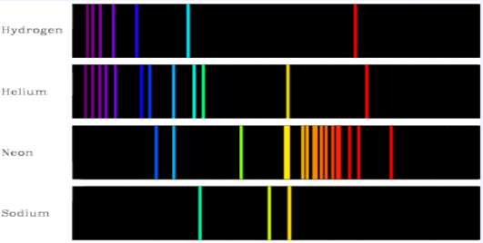

**Radioactivity**

Radioactive decay

* Alpha decay
  + Emits alpha particles: 2 protons 2 neutrons $\left({}_{2}^{4}α\right)$
  + Low penetrating power, blocked by a sheet of paper
* Beta decay
  + Emits beta particles: electrons $\left({}_{-1}^{0}β\right)$
  + Higher pp, blocked by a few mm of aluminium
* Gamma emission
  + Emits a photon, no mass and no charge $\left({}_{0}^{0}γ\right)$
  + When an excited nucleus falls into a lower energy state
  + Highest pp, stopped only by many cm of lead
* Exposure to radiation
  + Could break the bonds in exposed molecules, damage cells, irreversibly modify DNA, affects essential biological functions
* Reason for decay:
  + Existence of (fractionally charged) quarks in nuclei
  + Held together by a strong force that acts over very small distances
  + However, increase in neutrons, increase in electromagnetic repulsion and the weak force, can overcome the strong force, leading to decay

Nucleosynthesis

* The cosmic formation of atoms more complex than the hydrogen atom.
* Radioactive decay helped in synthesising many elements

Radionuclides

* Radioactively unstable nuclei
* Can be used to trace chemicals, pollutants, in nuclear medicine, radioactive dating
* Can be used to detect changes in the environment eg smoke detectors, or power instruments (heat generation)

Radiodating

* Half-life: time it takes for half the atoms to decay (avg rate)
* At any time:
 $$N\left(t\right)=N_{0}{\left(\frac{1}{2}\right)}^{\frac{t}{t_{\frac{1}{2}}}}=N_{0}e^{-λt}$$

 $λ=\frac{ln⁡(2)}{t_{\frac{1}{2}}}$ + where $λ$ = decay constant
* ${}_{6}^{14}C$ is unstable, 5700 years half-life, and is present in all living organisms (can be used in carbon dating)
* Above-ground nuclear bomb tests 🡪 sudden increases in Carbon-14 in the atmosphere
  + Temporary increased sensitivity of radiocarbon-dating

Body replacements

* Brain neurons: 20-30 years; eyes: never; muscle: 15 years; heart cells: 6 years; heart muscles: stop growing at 10; skeleton: 10 years
* Intestinal: 5 days; internal intenstinal: 16 years; liver: 300-500 days; red blood cells: 120 days; skin: 39 days

**Thermodynamics**

3 methods of heat transfer

* Conduction
  + Direct contact
  + $\frac{∆Q}{∆t}=\frac{kA(T_{2}-T_{1})}{d}$ (k = thermal conductivity, A = cross sectional area)
* Convection
  + Through a fluid
  + Temperature differences in a fluid lead to density changes
  + Eg if bottom is heated, lower density water rises, cooler and denser water sinks, heated at the bottom
* Radiation
  + Radiated through rays or particles
  + Pemitted by black-body
  + Blackbody radiation is across wavelengths generally, but most probable wavelength shortens with increasing temps

$λ_{peak}∝\frac{1}{T}$

Thermodynamics

* Zeroth law: If 2 systems are in thermal equilibrium with a third, they are in thermal eqm with each other
* First law: $∆U=Q-W$
  + U = internal energy of a system, Q = thermal energy received, W = work done by the system
* Second law: $∆S ≥0$
  + Change in entropy (disorder) of a system can never decrease
  + Irreversibility of processes
* Entropy (S) = $k_{B}\ln{Ω_{S}}$
  + $Ω_{S}$- the no. of microstates accessible to the system in a specified thermodynamic state
  + Q increases S; if a system receives Q at constant temp T, then $∆S ≥\frac{Q}{T}$
* Second law forbids spontaneous heat transfer fr a cold to hot place
  + A screenshot of a cell phone

    Description generated with very high confidenceIn a heat engine, in a refrigerator

**Circuits and Bioelectricity**

Electric potential

* Equi-potential lines
  + Perpendicular to electric field lines
  + Paths that charges can move w no work done on them by E field
* Electric potential energy
  + U = qV , where V = electric potential (aka EPE/unit charge)
  + $∆U=q∆V$ (change in EPE when moving charge q; path indep)

Electric circuits

* Potential difference measures amount of energy dissipated across different circuit elements
* Current (I)
  + Unit: Ampere, A = C/s
  + Flow of positive charges
* Resistance (R): V=RI
  + All circuit elements at finite temperatures have some resistance, hence a potential difference is necessary for current
  + Exception: superconductors have practically 0 resistance
  + Due to charge carries colliding with vibrating atoms in circuit
* Conductors
  + Conductors have loosely bonded electrons, delocalised
  + Small E fields will cause delocalised electrons to become mobile
  + Tend to have good thermal conductivity
* Insulators
  + Electrons strongly bonded to their atoms
  + Tend to be good thermal insulators
* Semi-conductors
  + Introducing dopant elements into materials with electrical conductivities between conductors and insulators
  + Create sites for charge carries to move about
* Electric power (W)
  + P = IV = I2R = V2/R

Bioelectricity

* Hydrolysis of ATP molecule 🡪 energy 🡪 ion pumps in body set up chemical gradient
  + Eg Sodium-potassium ion pump sets up a relatively higher concentration of Na outside the cell and of K inside the cell
* Typically, our cells are negatively charged due to ion exchange
  + Cell membrane potential can switch
  + Depolarise/repolarise, allowing transmission of localised potential differences over the membrane surface
* Neurons signal to each other via action potentials on their axons
  + Propogated via a depolarisation wavefront

**Waves**

Properties

* Amplitude, period (T), frequency (f = 1/T), angular frequency $ω=\frac{2π}{T}$
* $v=fλ$ (speed = freq*wavelength)

Transport

* Transmission of energy
* Intensity (I), output power (P = E/t) and distance (R)
$$I=\frac{P}{4πR^{2}}$$

* Longitudinal waves: propagation parallel to displacement
* Transverse wave: propagation perpendicular to displacement ~
* Determining mediums
  + A medium can only sustain transverse/longitudinal waves if there are restoring forces in the right direction

Light waves

* A close up of text on a white background

  Description generated with high confidenceLight is essentially a travelling packet of transverse electric and magnetic field disturbance
  + Magnetic and electric fields are perpendicular to each other
  + Speed of light in a vacuum c = 3.0 x 108m/s
* Spectrum of light is observed due to photoreceptors in our eyes responding to different wavelengths of light
  + Visible light = 390 to 700 nm (10-9m)

Sound waves

* Travelling packets of longitudinal disturbance
  + Compressions and rarefactions
* We can hear frequencies/pitches between 20Hz - 20kHz
  + 20kHz - 2MHz: used for medical & destructive work
  + 2MHz - 200MHz: used for diagnostic & NDE
* Ultrasound imaging
  + Measures strength and delay time of reflected ultrasonic waves sent into imaging region
* How we hear
  + Sounds vibrate ear drum, drives ossciles (tiny bones), pull/push on fluid inside cochlea (inside ear), send electrical stimuli to brain
* Doppler effect
  + Pitch of a moving sound differs based on whether it is moving toward or way from you
  + Receding source
 $$f_{observed}=\frac{v}{v+v_{source}}f_{source}$$

 + Approaching source
 $$f_{observed}=\frac{v}{v-v_{source}}f_{source}$$

 + Speed of moving objects (eg blood cells) can be measured by up/down-shift of freq of reflected ultrasound waves
  + Doppler shift = $f_{ref}-f_{trans}=\frac{2f_{o}v\cos{θ}}{c}$

**Geometric Optics**

Fermat’s principle of least time

* Propagation of light waves take on trajectories that minimise time
  + Light rays take straight paths in the absence of obstacles
  + Reflected light takes the shortest time path
  + Direction of light reversible in determining shortest path

Reflection and Refraction

* Characteristics of wave velocity: phase and group velocity
  + Phase velocity, cp = f $λ$: how fast the nodes of a wave travel
  + Group velocity: speed at which info is transmitted, speed of wavepacket
* Refraction
  + *A picture containing object

    Description generated with very high confidence*Apparent wavelength of light in a medium: $λ_{n}=\frac{λ}{n}$ (where n = medium’s index of refraction)
  + Change in phase velocity: $c_{n}=\frac{c_{0}}{n}$
  + Frequency of light stays the same
  + Snell’s law: $\frac{n_{1}}{n_{2}}=\frac{\sin{θ_{2}}}{\sin{θ_{1}}}$
  + Light of different wavelengths have different refractive indices

Lenses

* Power (P) = 1/f (focal length)
  + Decreasing the radius of curvature = increase optical power
* Thin lenses
  + 1. Parallel light incident on a thin lense converges as the back focal plane of the lens
  + 2. Light passing through the center of the lens does not bend
  + 3. Intersection of rays determine where the ideal image of an object is formed
* I = image distance, o = obj dist
 $\frac{1}{i}+\frac{1}{o}=\frac{1}{f}$

 + If o < f, virtual, upright image formed
  + If o>f, real, inverted image formed
* *A close up of a map

  Description generated with high confidence*Magnification
  + M =

*A picture containing text

Description generated with very high confidence*

**Cameras and** **Vision**

Camera

* Resolution: smallest feature you can see
* Contrast: visual difference between colours
* A picture containing text, map

  Description generated with very high confidencePinhole camera
  + Using a pinhole aperture forms high resolution images by being selective about which light rays are used to form images
* Circle of confusion
  + Real lenses focuses parallel light imperfectly, to a ‘circle’ of least confusion
  + If the circle of confusion is smaller than the size of its pixel, practically in focus
  + Depth of focus: range of nearest and farthest objects that appear acceptably sharp in an image
* Camera detectors
  + Pixel-wise frequency filters to select for particular colours

Vision

* The eye also has an aperture (iris), a lens, a detector (retina)
* The cornea forms the front surface of the eye
  + Accounts for ~80% of the optical power of our eye
  + Fixed refractive index and shape
  + LASIK operations alter the thickness and shape of the cornea
* The crystalline lens is formed from proteins, accounts for ~20% of the optical power of the eye
  + Optical power can be adjusted by changing the curvature
* Vision problems
  + Optical power (1/f) units: diopters (1/m)
  + Normal human vision: 58.8 to 41.6 diopters
* Iris controls the size of our pupil
  + Also regulates amount of light reaching our retina
* Cone and rod cells on our retina detect incident light
  + Cone cells detect colours, rod cells do not
  + The retina’s fovea centralis has the highest cone density/highest visual acuity for detecting colour
  + Rod cells see night vision, motion detection, peripheral vision
* Blind spot: where our optic nerve meets the retina